**Part I: Business Description**

A new animal hospital is opening and will offer both scheduled appointments and emergency room visits for all animal patients. The animal hospital must configure a database to track information about the patients, their owners, appointments made, emergency visits that occured, examinations/treatments administered by a veterinarian during each visit, medicine prescribed and invoices for the patients’ owners.

The patients’ owners are the direct contact for the animal hospital and will be receiving invoices based on their animal’s examinations, treatments and medicine. Therefore, accurate contact information is necessary for patients’ owners, including phone numbers, addresses, and email addresses. Each patient’s record must detail the animal’s name, species, breed, age, gender, and what examinations/treatments are required as well as the medicine that will be prescribed to the animal. Each visit will detail the veterinarian examining the animal, date and time, and results of the visit. An examination/treatment may result in the veterinarian providing medication to the animal. Afterwards, an invoice will be sent to the owner that will detail the description of the service, amount due and the payment due date.

With the new database, the hospital can better track each patient coming in, their needs, and later on track payments coming in from the owners creating a more efficient system.

**Part II: Entity Relationship**

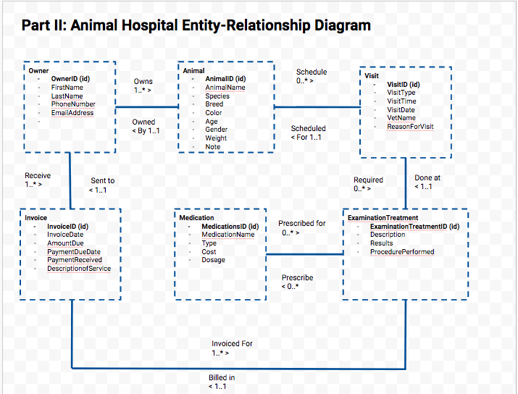

**Part III: Animal Hospital Relational Model**

**Owner** ( **OwnerID (key**), FirstName, LastName, PhoneNumber, EmailAddress )

**Animal** ( **AnimalID (key)**, AnimalName, Species, Breed, Color, Age, Gender, Weight, Note, **OwnerID (fk)** )

**Invoice** ( **InvoiceID (key**), InvoiceDate, AmountDue, PaymentDueDate, PaymentReceived, DescriptionofService, **OwnerID (fk)** )

**Visit** ( **VisitID (key)**, VisitType, VisitDate, VisitTime, ReasonForVisit, VetName, **AnimalID (fk)** )

**ExaminationTreatment** ( **ExaminationTreatementID (key)**, Description, Results, ProcedurePerformed, **EmergencyVisitID (fk), InvoiceID (fk)**)

**Medication** ( **MedicationID (key)**, MedicationName, Type, Cost, Dosage )

**ExaminationTreatment_Medication** ( **ExaminationTreatmentID (key)(fk), MedicationID (key)(fk)**)

**Part III: Normalization Proofs**

**Owner** ( **OwnerID (key**), FirstName, LastName, PhoneNumber, EmailAddress )

**FD1:** OwnerID → FirstName, LastName, PhoneNumber, EmailAddress.

**1NF?** Yes. Reason: Given that Owner is a relation.

**2NF?** Yes. Reason: No partial key dependencies.

**3NF?** Yes. Reason: No transitive dependencies

**Animal** ( **AnimalID (key)**, AnimalName, Species, Breed, Color, Age, Gender, Weight, Note, **OwnerID (fk)** )

**FD1:** AnimalID → AnimalName, Species, Breed, Color, Age, Weight, Gender, Note, OwnerID

**FD2:** Breed → Species

**1NF?** Yes. Reason: Given that Animal is a relation.

**2NF?** Yes. Reason: No partial key dependencies.

**3NF?** No. Reason: Transitive dependency Species → Breed

**Animal** ( **AnimalID (key)**, AnimalName, Color, Age, Gender, Weight, Note, **OwnerID (fk), BreedSpecies(fk)**)

**FD1:** AnimalID → AnimalName, Color, Age, Weight, Note, OwnerID, SpeciesBreed

**1NF?** Yes. Reason: Subrelations of a relation are also relations.

**2NF?** Yes. Reason: No partial key dependencies.

**3NF?** Yes. Reason: No transitive dependencies

**BreedSpecies** (**Breed(key),** Species)

**FD1:** Breed → Species

**1NF?** Yes. Reason: Subrelations of a relation are also relations.

**2NF?** Yes. Reason: No partial key dependencies.

**3NF?** Yes. Reason: No transitive dependencies

**Invoice** ( **InvoiceID (key**), InvoiceDate, AmountDue, PaymentDueDate, PaymentReceived, DescriptionofService, **OwnerID (fk)** )

**FD1**: InvoiceID → InvoiceDate, AmountDue, PaymentDueDate, PaymentReceived, DescriptionofService, OwnerID

**FD2:** DescriptionofService → AmountDue

**1NF?** Yes. Reason: Subrelations of a relation are also relations.

**2NF?** Yes. Reason: No partial key dependencies.

**3NF?** No. Reason: Transitive dependency DescriptionofService → AmountDue

**Invoice** ( **InvoiceID (key**), InvoiceDate, PaymentDueDate, PaymentReceived, **OwnerID (fk), ServiceAmount (fk)** )

**FD1:** InvoiceID → InvoiceDate, PaymentDueDate, PaymentReceived, OwnerID, ServiceAmount

**1NF?** Yes. Reason: Subrelations of a relation are also relations.

**2NF?** Yes. Reason: No partial key dependencies.

**3NF?** Yes. Reason: No transitive dependencies

**ServiceAmount** ( **DescriptionofServiceID (key)**, AmountDue )

**FD1**: DescriptionofService → AmountDue

**1NF?** Yes. Reason: Subrelations of a relation are also relations.

**2NF?** Yes. Reason: No partial key dependencies.

**3NF?** Yes. Reason: No transitive dependencies

**Visit** (**VisitID (key)**, VisitType, VisitDate, VisitTime, ReasonForVisit, VetName, **AnimalID (fk)**)

**FD1:** VisitID → VisitType, VisitDate, VisitTime, ReasonForVisit, VetName, AnimalID

**1NF?** Yes. Reason: Subrelations of a relation are also relations.

**2NF?** Yes. Reason: No partial key dependencies.

**3NF?** Yes. Reason: No transitive dependencies

**ExaminationTreatment** ( **ExaminationTreatmentID (key)**, Description, Results, ProcedurePerformed, **VisitID (fk)**, **InvoiceID (fk)**)

**FD1**: ExaminationTreatmentID →Description, Results, ProcedurePerformed, InvoiceID

**1NF?** Yes. Reason: Yes, this is a relation.

**2NF?** Yes. Reason: No partial key dependencies.

**3NF?** Yes. Reason: No transitive dependencies.

**Medication** ( **MedicationID (key)**, MedicationName, Type, Cost, Dosage )

**FD1:** MedicationID → MedicationName, Type, Cost, Dosage

**1NF?** Yes. Reason: Yes, this is a relation.

**2NF?** Yes. Reason: No partial key dependencies.

**3NF?** Yes. Reason: No transitive dependencies

**ExaminationTreatment_Medication** ( **ExaminationTreatmentID (key)(fk), MedicationID (key)(fk)**)

**1NF?** Yes. Reason: Yes, this is a relation.

**2NF?** Yes. Reason: No partial key dependencies.

**3NF?** Yes. Reason: No transitive dependencies

**NEW SET OF RELATIONS:**

**Owner** ( **OwnerID (key**), FirstName, LastName, PhoneNumber, EmailAddress )

**Animal** ( **AnimalID (key)**, AnimalName, Color, Age, Gender, Weight, Note, **OwnerID (fk), BreedSpecies(fk)**)

**BreedSpecies** (**Breed(key),** Species)

**Invoice** ( **InvoiceID (key**), InvoiceDate, PaymentDueDate, PaymentReceived, **OwnerID (fk), AmountDue (fk)** )

**ServiceAmount** ( **DescriptionofService (key)**, AmountDue )

**Visit** ( **VisitID (key)**, VisitDate, VisitTime, ReasonForVisit, VetName, IsEmergency, **AnimalID (fk)** )

**ExaminationTreatment** ( **ExaminationTreatmentID (key)**, Description, Results, ProcedurePerformed, **VisitID (fk)**, **InvoiceID (fk)**)

**Medication** ( **MedicationID (key)**, MedicationName, Type, Cost, Dosage )

**ExaminationTreatment_Medication** ( **ExaminationTreatmentID (key)(fk), MedicationID (key)(fk)**)

**Description of each Query:**

1. Who has outstanding invoices as of 12/5/2020? To help identify which invoices are still outstanding as of 12/5/20 and requires collection.
2. Total invoice amount paid in April 2020? Allow the hospital to predict the amount of expected revenue for next April.
3. What is the most expensive medication? To help the animal hospital know which medication costs the most.
4. How often was the most expensive medicine prescribed after an examination? To help the animal hospital know the number of times the most expensive medication was prescribed.
5. Who was prescribed Parasiticide? A possible recall on the medication has been issued and the hospital may want to see who has been prescribed it recently to see who may be in danger.
6. Who were the animals that had emergencies in 2020 so far? We will be able to identify which animals are the most susceptible to emergencies and price our services accordingly.
7. What upcoming appointments do Dr. Marks have for the month of December 2020? We will be able to identify the availability for a certain veterinarian.